

CSC 1300 LAB 12 – esports players
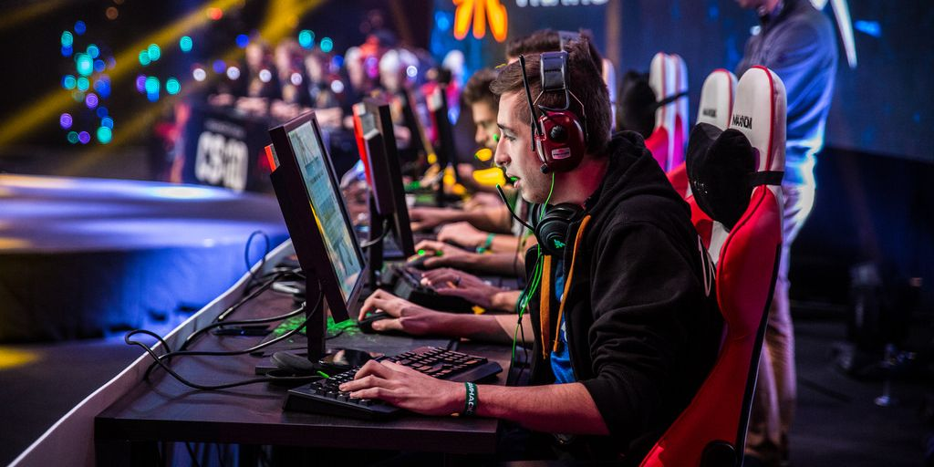

Concepts
- Structures
- Pointers
- Dynamic Memory Allocation

Description
Your program should allow the user to enter in how many players play esports (who is also a CSC major at TTU). Then, you will ask for each player’s name, hometown, age, and how many esports games he/she plays. Then you will ask how many hours the player plays of each esport game. Then you will print out which player has the most hours (and print the player’s name) and also which player has the least hours (and print the player’s name).

Specifications
- Name your program lab12.cpp
- Create your Player structure which should contain two strings (name & hometown) and two integers (age & numGames).
- Ask how many esports players are there at TTU who major in CSC and read that in. 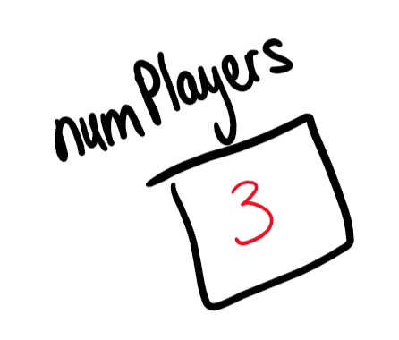
- Dynamically allocate an array of Player elements based on the number of esports players you just read in.
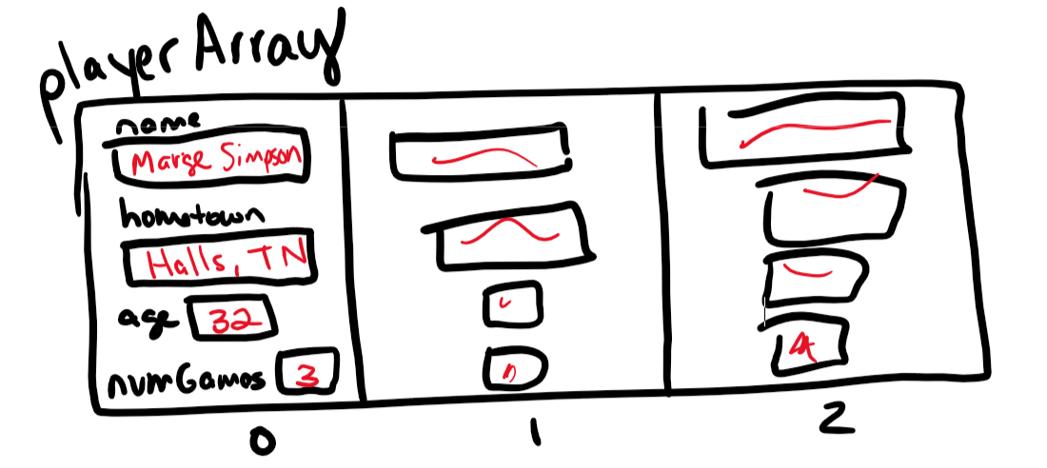
- Dynamically allocate an array of pointers-to-integers based on the number of esports players you just read in. This array will hold the number of hours for each esports game for each player (like a 2D array)
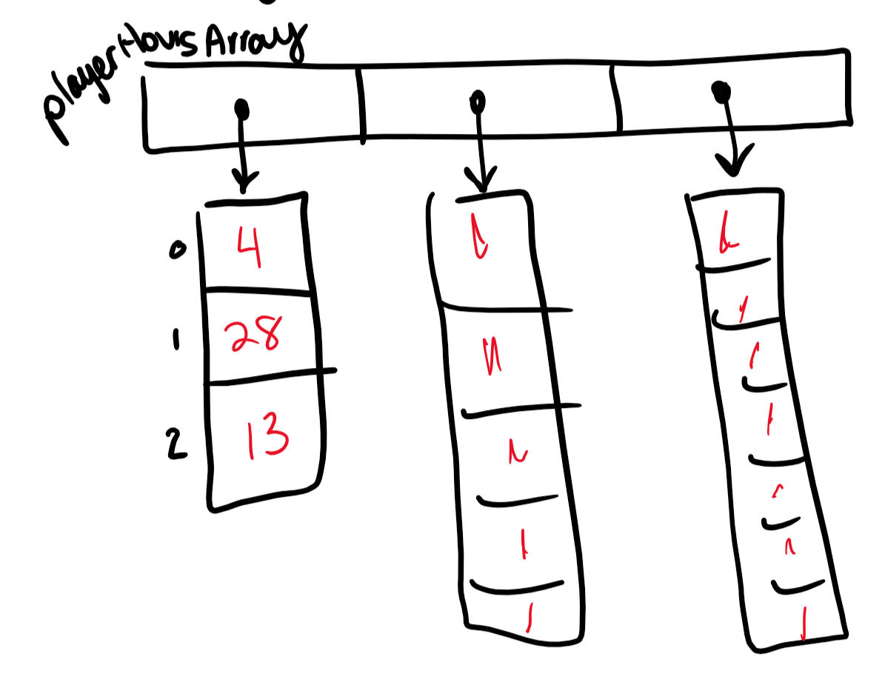
- Allow the user to enter in information about each player and fill up the appropriate array. The player’s name and hometown should be able to contain spaces. The player’s name, hometown, age, and number of games they play should go in the Player array. The number of hours for each game should go in the player’s hours array. Refer to the sample output to read what you should be asking for and how it should look.
- Calculate & print out the most hours spent (combining hours for all games for each player) and also the least hours spent. Make sure to print the name of the player along with their total hours for each of these. Refer to the sample output. You may want to use the numeric_limits class to initialize the most hours variable to std::numeric_limits<int>::min() and the least hours variable to std::numeric_limits<int>::max() before the loop to find out who has the most and who has the least.

Sample Output
User input is highlighted in yellow in the sample output below.
How many esports players are there at TTU who major in CSC?
6

Please enter in information about each player:

PLAYER 1:
NAME: Zac Morris
HOMETOWN: Jamestown, TN
AGE: 20
HOW MANY GAMES DOES Zac Morris PLAY? 10
NUMBER OF HOURS Zac Morris PLAYED GAME 1 3
NUMBER OF HOURS Zac Morris PLAYED GAME 2 99
NUMBER OF HOURS Zac Morris PLAYED GAME 3 3
NUMBER OF HOURS Zac Morris PLAYED GAME 4 49
NUMBER OF HOURS Zac Morris PLAYED GAME 5 2
NUMBER OF HOURS Zac Morris PLAYED GAME 6 4
NUMBER OF HOURS Zac Morris PLAYED GAME 7 39
NUMBER OF HOURS Zac Morris PLAYED GAME 8 4
NUMBER OF HOURS Zac Morris PLAYED GAME 9 889
NUMBER OF HOURS Zac Morris PLAYED GAME 10 3

PLAYER 2:
NAME: Jessie Spano
HOMETOWN: Nashville, TN
AGE: 19
HOW MANY GAMES DOES Jessie Spano PLAY? 3
NUMBER OF HOURS Jessie Spano PLAYED GAME 1 2
NUMBER OF HOURS Jessie Spano PLAYED GAME 2 4
NUMBER OF HOURS Jessie Spano PLAYED GAME 3 9

PLAYER 3:
NAME: A.C. Slater
HOMETOWN: Lenoir City, TN
AGE: 20
HOW MANY GAMES DOES A.C. Slater PLAY? 5
NUMBER OF HOURS A.C. Slater PLAYED GAME 1 24
NUMBER OF HOURS A.C. Slater PLAYED GAME 2 33
NUMBER OF HOURS A.C. Slater PLAYED GAME 3 57
NUMBER OF HOURS A.C. Slater PLAYED GAME 4 3
NUMBER OF HOURS A.C. Slater PLAYED GAME 5 2

PLAYER 4:
NAME: Kelly Kapowski
HOMETOWN: Hendersonville, TN
AGE: 18
HOW MANY GAMES DOES Kelly Kapowski PLAY? 2
NUMBER OF HOURS Kelly Kapowski PLAYED GAME 1 9444
NUMBER OF HOURS Kelly Kapowski PLAYED GAME 2 2

PLAYER 5:
NAME: Richard Belding
HOMETOWN: Chattanooga, TN
AGE: 50
HOW MANY GAMES DOES Richard Belding PLAY? 1
NUMBER OF HOURS Richard Belding PLAYED GAME 1 20

PLAYER 6:
NAME: Lisa Turtle
HOMETOWN: Sparta, TN
AGE: 21
HOW MANY GAMES DOES Lisa Turtle PLAY? 6
NUMBER OF HOURS Lisa Turtle PLAYED GAME 1 28
NUMBER OF HOURS Lisa Turtle PLAYED GAME 2 65
NUMBER OF HOURS Lisa Turtle PLAYED GAME 3 43
NUMBER OF HOURS Lisa Turtle PLAYED GAME 4 88
NUMBER OF HOURS Lisa Turtle PLAYED GAME 5 65
NUMBER OF HOURS Lisa Turtle PLAYED GAME 6 9009

The player who played the most hours (9446 hours) is Kelly Kapowski

The player who played the least hours (15 hours) is Jessie Spano

